- This week's UK data releases reported a further cooling in wage growth and more job losses, while underlying price pressures remained stable. The data provided no reason to think the Monetary Policy Committee will deviate from the gradual path of rate cuts signalled in December, so Bank Rate is likely to remain unchanged at 3.75% in February.
- The mildly stagflationary environment looks set to endure, with activity likely to underwhelm and stickiness in core inflation and pay growth. Under such tricky policymaking conditions, we think a majority of committee members will be content with waiting until the end-April meeting before loosening policy again.
The minutes of December's Monetary Policy Committee meeting signalled that there was little appetite among the majority of committee members to loosen policy again in the near term. This week's wealth of data releases offered the first potential challenge to that stance.
The first of those, Tuesday's labour market release, helped to build the case for further gradual cuts to Bank Rate. On the quantities side, the Office for National Statistics reported that the unemployment rate held steady at 5.1% in the three months to November, though November's elevated single-month reading suggested that the jobless rate is likely to climb higher in the near term.
Widely publicised issues with the ONS' Labour Force Survey mean we place less weight on the unemployment estimates. But other indicators that are unaffected by these issues also pointed to a further loosening in labour market conditions. Most notably, HMRC's count of payrolled employees fell by 43,000 in December, after a 33,000 drop in payrolls a month earlier (Chart 1).
We know that the HMRC measure tends to be heavily revised, and that in recent years those revisions have tended to be upwards. But these falls were the biggest we've seen since late-2020. And signs of renewed weakness in the payrolls data chime with the results from a range of business surveys and alternative indicators that suggest the jobs market is in poor shape, with the degree of slack continuing to build.
Chart 1: HMRC's latest count of payrolled employees points to renewed weakness in the jobs market
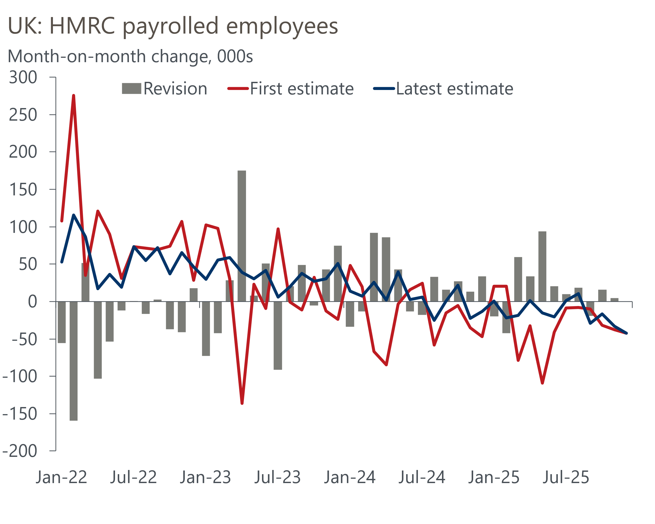
Source: Oxford Economics calculations using data from ONS

The labour market release also showed that pay growth continued to cool, with headline (three-month average of the annual rate) private sector regular pay growth – the Bank of England's favoured measure – easing to 3.6% in November. This reflected a combination of favourable base effects and weak momentum.
Indeed, the three-month-on-three-month annualised rate – a better guide to recent momentum – remained comfortably below 3% for the second consecutive release. This is consistent with the pace the MPC considers to be consistent with achieving the inflation target over the medium term. But it was clear from December's minutes that, based on intelligence from its regional agents, the MPC is concerned that pay settlements will rise again in the early part of this year. Whether or not this happens will be key to the extent that the MPC loosens policy this year.
Wednesday's inflation release painted a less dovish picture. CPI inflation rose 0.2ppts to 3.4% in December, though this was largely due to earlier weaker outturns in several notoriously volatile core sub-categories, such as air fares, accommodation services, and clothing, partially unwinding in December. Meanwhile, the 2025 Budget uprating of tobacco duty also raised headline inflation in December, with the 2024 increase having occurred a month earlier.
Looking through this noise, the underlying story was mixed. On the one hand, both headline and services inflation came in slightly below the BoE's most recent staff forecast. But on the other hand, the fall in headline inflation over recent months has come despite the MPC's preferred measure of core services inflation remaining virtually unchanged (Chart 2).
Chart 2: Services inflation edged higher in December, but underlying pressures were stable
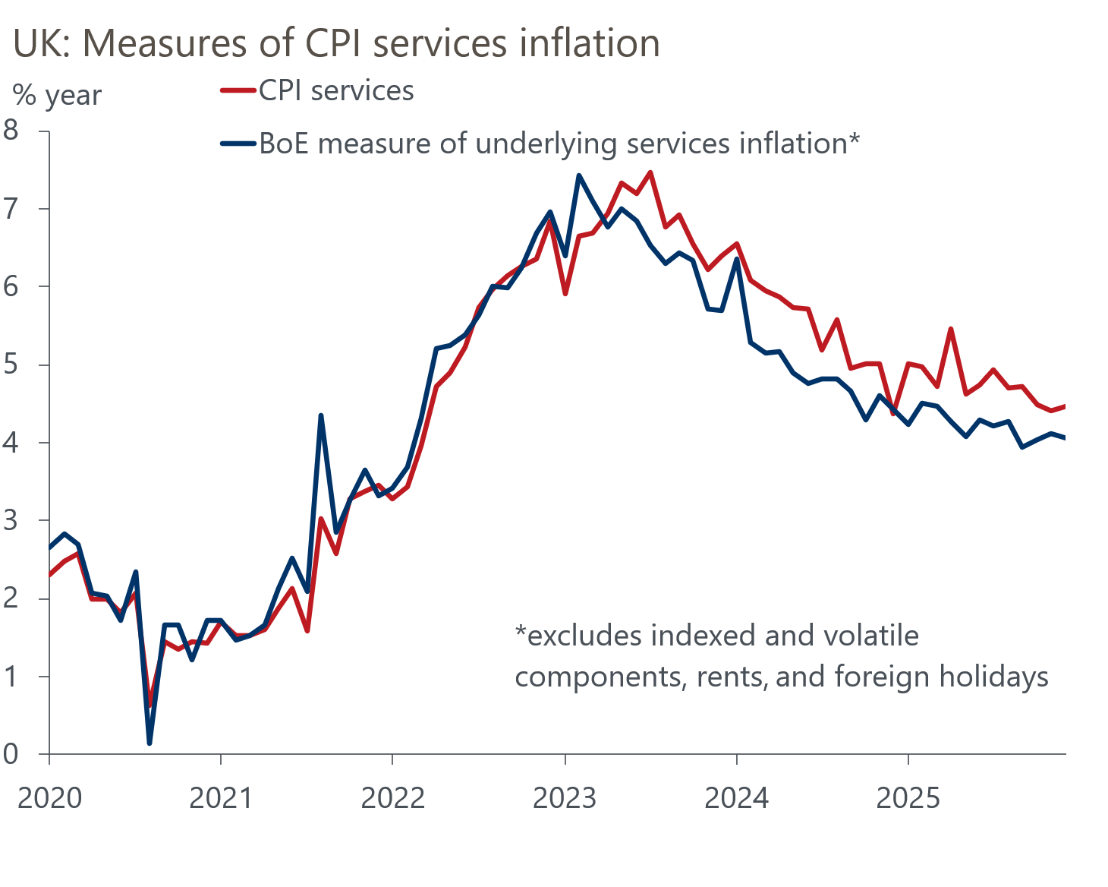
Source: Oxford Economics calculations using data from Haver Analytics
The week's activity data was better, with retail sales rising in December and the composite PMI surging to a near two-year high in January. But we're sceptical that either offer a true reflection of the strength of activity, given that both have been very volatile and revision prone of late. We still expect 2026 to be a challenging year, with strong domestic headwinds keeping GDP growth below 1%.
The MPC has put forward two alternative scenarios for the economic outlook. The first showed an upside risk to inflation, with elevated inflation expectations keeping pay growth above a target-consistent pace. The second showed downside risks to inflation from greater weakness in output, especially consumer spending. Most MPC members believe that one or the other is more likely to occur.
But as we argued in a recent Research Briefing, the scenarios are not mutually exclusive. The mildly stagflationary environment that the UK finds itself in means elements of both scenarios are likely to materialise. This presents a problem for the MPC, and will likely encourage a cautious approach.
Concerns about the strength of 2026 pay awards will likely mean that a majority of members will be content to sit back and wait for a clearer view on how that element is playing out. This points to the end-April meeting as the likely timing for the next cut. And we think the desire to move cautiously will see the MPC only cut once more in the second half of the year.

The week ahead
Next week should prove much quieter, with the Bank of England's Money & Credit data for December the only major release of note. After a slightly weaker print in November, we expect mortgage approvals to have risen to 65,000 in December, from 64,500 a month earlier, as potential buyers responded to the fall in quoted mortgage rates in the latter months of last year.
Net secured lending has been noisy in recent months, largely reflecting swings in gross lending. We think a partial unwinding of slightly softer gross lending outturns in October and November is likely to have supported a modest pickup in net lending in December. We project that net mortgage lending rose to £4.8bn, from £4.5bn in November.
On the unsecured side, an upturn in gross lending drove November's rise in net lending. However, we think this rise in gross lending is unlikely to have been sustained in December. As a result, we estimate that net unsecured lending fell back to £1.7bn in December, down from £2.1bn in November.
Table 1: Week ahead calendar
Date | Events | Period | Measure | Unit | Previous | Forecast
Jan 30 | Nationwide house prices | Jan | m/m | % | -0.4 | 0.2
Jan 30 | Nationwide house prices | Jan | y/y | % | 0.6 | 0.6
Jan 30 | Mortgage approvals | Dec | Level | 000s | 64.5 | 65.0
Jan 30 | Mortgage lending | Dec | Net lending | £bn | 4.5 | 4.8
Jan 30 | Consumer credit | Dec | Net lending | £bn | 2.1 | 1.7
Source: Oxford Economics

Key forecasts
Table 2: UK forecast overview
(Annual percentage changes unless specified)
 | 2023 | 2024 | 2025 | 2026 | 2027 | 2028
GDP | 0.3 | 1.1 | 1.4 | 0.9 | 1.4 | 1.5
Private consumption | -0.3 | -0.1 | 0.9 | 1.1 | 1.1 | 1.4
Fixed investment | 0.5 | 1.7 | 3.2 | 0.9 | 2.1 | 2.1
Government consumption | 2.1 | 2.9 | 1.8 | 2.1 | 1.7 | 1.4
Exports of goods and services | -2.3 | 1.4 | 2.1 | 0.9 | 1.1 | 1.3
Imports of goods and services | -1.6 | 2.7 | 4.2 | 0.4 | 1.2 | 1.4
Industrial production | -2.6 | -1.3 | 0.5 | 0.6 | 1.1 | 1.2
Consumer prices | 7.3 | 2.5 | 3.4 | 2.3 | 2.5 | 2.3
Unemployment rate (%) | 4.1 | 4.3 | 4.8 | 5.2 | 5.0 | 4.7
Current a/c balance (% of GDP) | -3.6 | -3.0 | -2.9 | -3.0 | -2.8 | -2.6
Government balance (% of GDP) | 5.2 | 5.3 | 5.0 | 3.9 | 3.3 | 2.8
Central bank policy rate (%, EOP) | 5.25 | 4.75 | 3.75 | 3.25 | 3.00 | 2.75
10yr govt. bond yield (%, EOP) | 3.54 | 4.57 | 4.47 | 4.38 | 3.90 | 3.64
Exchange rate (US$ per £, EOP) | 1.27 | 1.25 | 1.35 | 1.29 | 1.29 | 1.29
Exchange rate (euro per £, EOP) | 1.15 | 1.21 | 1.15 | 1.11 | 1.11 | 1.11
Source: Oxford Economics
Table 3: Quarterly forecasts for the UK
 | 2025 |  |  |  | 2026
 | Q1 | Q2 | Q3 | Q4 | Q1 | Q2 | Q3 | Q4
GDP (% year) | 1.8 | 1.4 | 1.3 | 1.1 | 0.7 | 0.7 | 0.9 | 1.1
CPI inflation (% year) | 2.8 | 3.5 | 3.8 | 3.4 | 3.0 | 1.9 | 2.0 | 2.3
Bank Rate (%, EOP) | 4.50 | 4.25 | 4.00 | 3.75 | 3.75 | 3.50 | 3.50 | 3.25
10yr gilt yield (%, EOP) | 4.70 | 4.48 | 4.70 | 4.47 | 4.50 | 4.48 | 4.45 | 4.38
US$ per £ (EOP) | 1.29 | 1.37 | 1.35 | 1.35 | 1.30 | 1.29 | 1.29 | 1.29
Euro per £ (EOP) | 1.20 | 1.17 | 1.15 | 1.15 | 1.12 | 1.11 | 1.11 | 1.11
Source: Oxford Economics

Latest Country Economic Forecast:
January 22, 2026

Recent publications

Data Insights
January PMI looks too good to be true
Quiet end to the year for the retail sector
Budget didn’t cure public finances' fragility
December's inflation pickup will prove temporary
Softer labour market data won't trigger a February rate cut

Research Briefings
Alternative indicators point to subdued economy
Mild stagflation is likely to keep MPC divided
Will Greenland be the catalyst for a new trade war?
Why higher term premia will slow the fall in gilt yields
MPC cuts, but emphasises the need for caution in 2026

Contacts

Oxford Economics' UK team
- Andrew Goodwin - Chief UK Economist - agoodwin@oxfordeconomics.com
- Edward Allenby - Senior UK Economist - eallenby@oxfordeconomics.com

